Pay for 4 Quarts and receive 2 extra Quarts FREE!

YOU PICK ANY 6 COLORS

- (2) (3) (4) (5) FREE! (6) FREE!
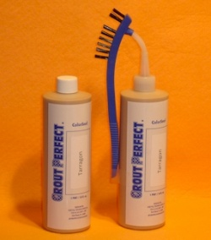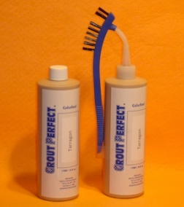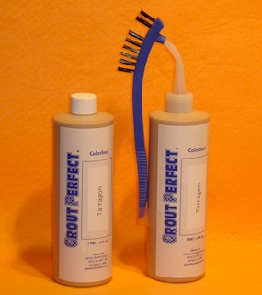
Type in color and Type in color and Type in color and Type in color and Type in color and Type in color and
manufacturer manufacturer manufacturer manufacturer manufacturer manufacturer

PLUS
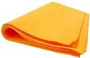
PLUS: (6) – 27” X 20” MicroFiber Shammy Sheets FREE!

ALL THIS for only $316.00 + S&H

That’s enough GROUT PERFECT Grout ColorSeal to complete
approximately 6,000 square feet of tile floor based upon 12X12 tile and skill level.
That makes the ColorSeal cost less than 5¢ per square foot.

NAME | DATE
COMPANY NAME | BILLING ADDRESS
SHIPPING ADDRESS | BILLING CITY, STATE & ZIP CODE
SHIPPING CITY, STATE & ZIP CODE | CREDIT CARD NO.
PHONE | EXPIRATION DATE
E-MAIL | 3 OR 4 DIGIT SECURITY CODE
Either complete this order form online and e-mail to GPOrders@GroutPerfect.com or complete and fax to 877-767-3379. Void where prohibited. 7% sales tax will be applied to all Florida customers.

